Now we need to create three more files normally

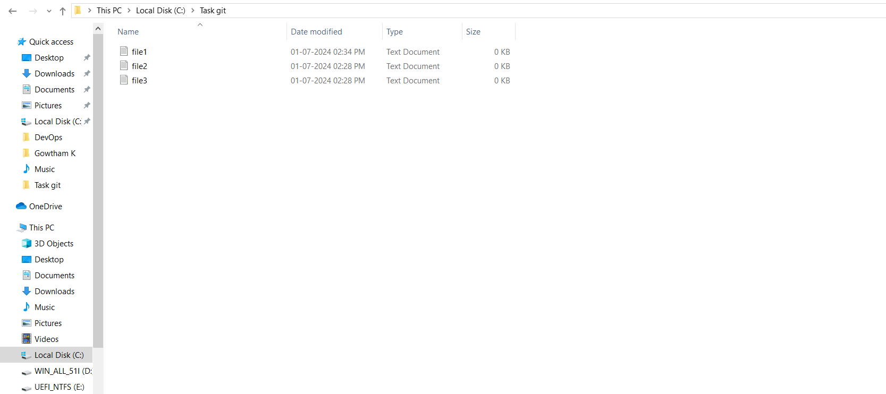 Now we need to create new branch first_branch

**git branch first-branch**

To check list of branch

**git branch**

Now get in to new branch

**git checkout first-branch**

Now we need to add file3 and commit it

**git add file1.txt**

**git commit –m “commit file1.txt”** 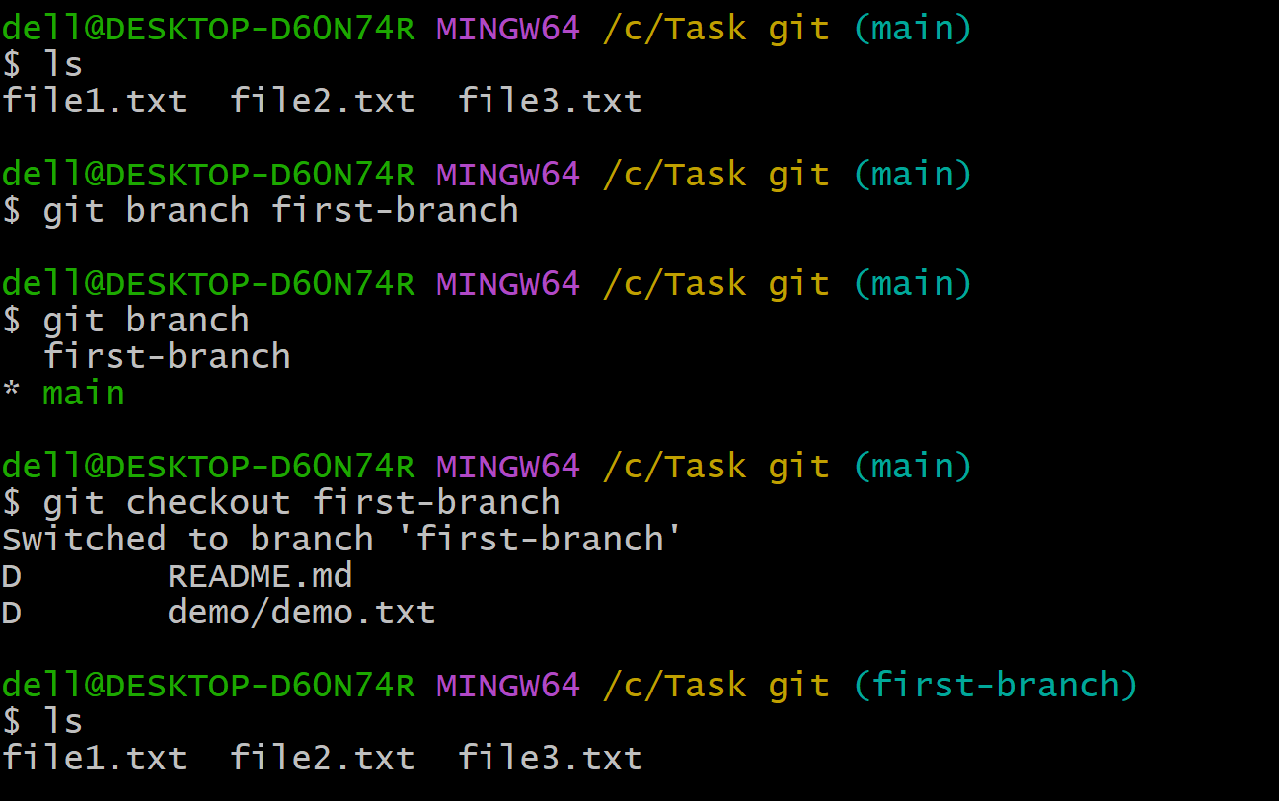 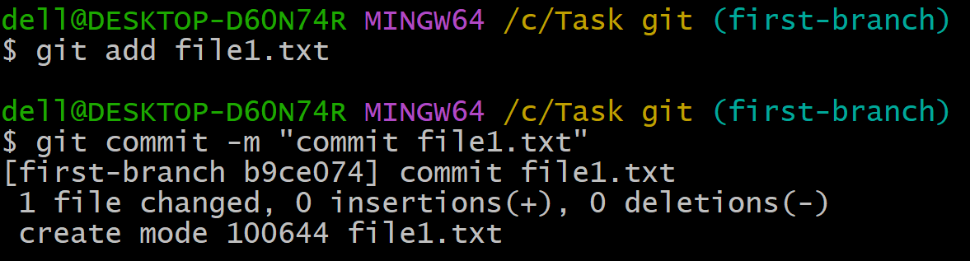 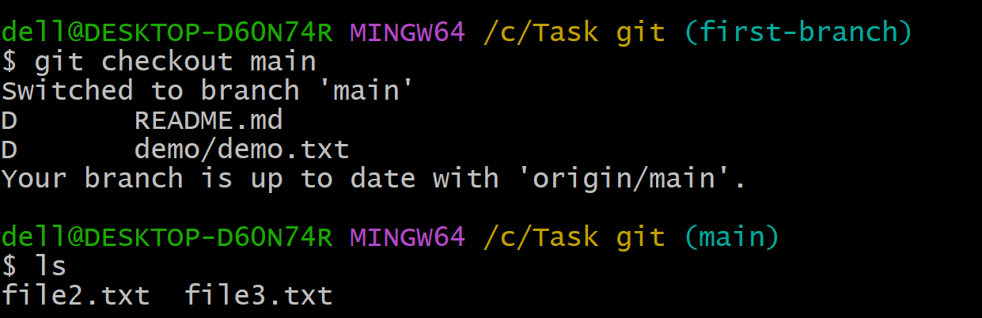 Now if we see first-branch as access to all files but master branch doesn’t have file1.txt as we committed in first-branch only

In order to merge the file from first_branch to master branch

**git merge first_branch**

When you’re merging you need to be in the branch where you want file to come.

